I asked Andrea to move my skill level to Beginner. Previously, she asked if I wanted to level up to intermediate. I should be able to tell her in the chat that I want to be able to change my level, rather than just waiting for her to recommend it.
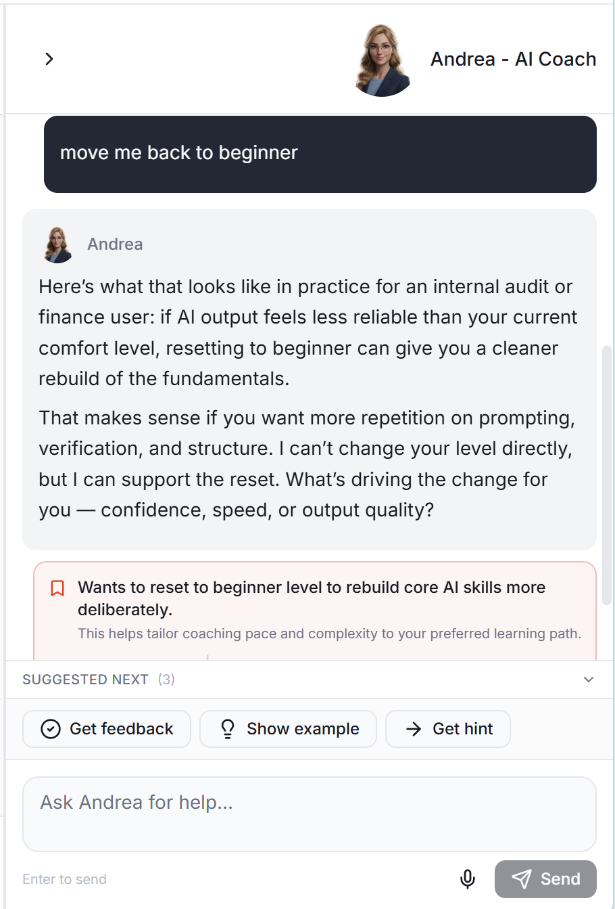

What criteria does Andrea monitor for to determine the AI skillset level during the users completion of modules.

The responses in the main pane are a wide range of fonts. It should all be the same font as the interactions with Andrea in the right pane.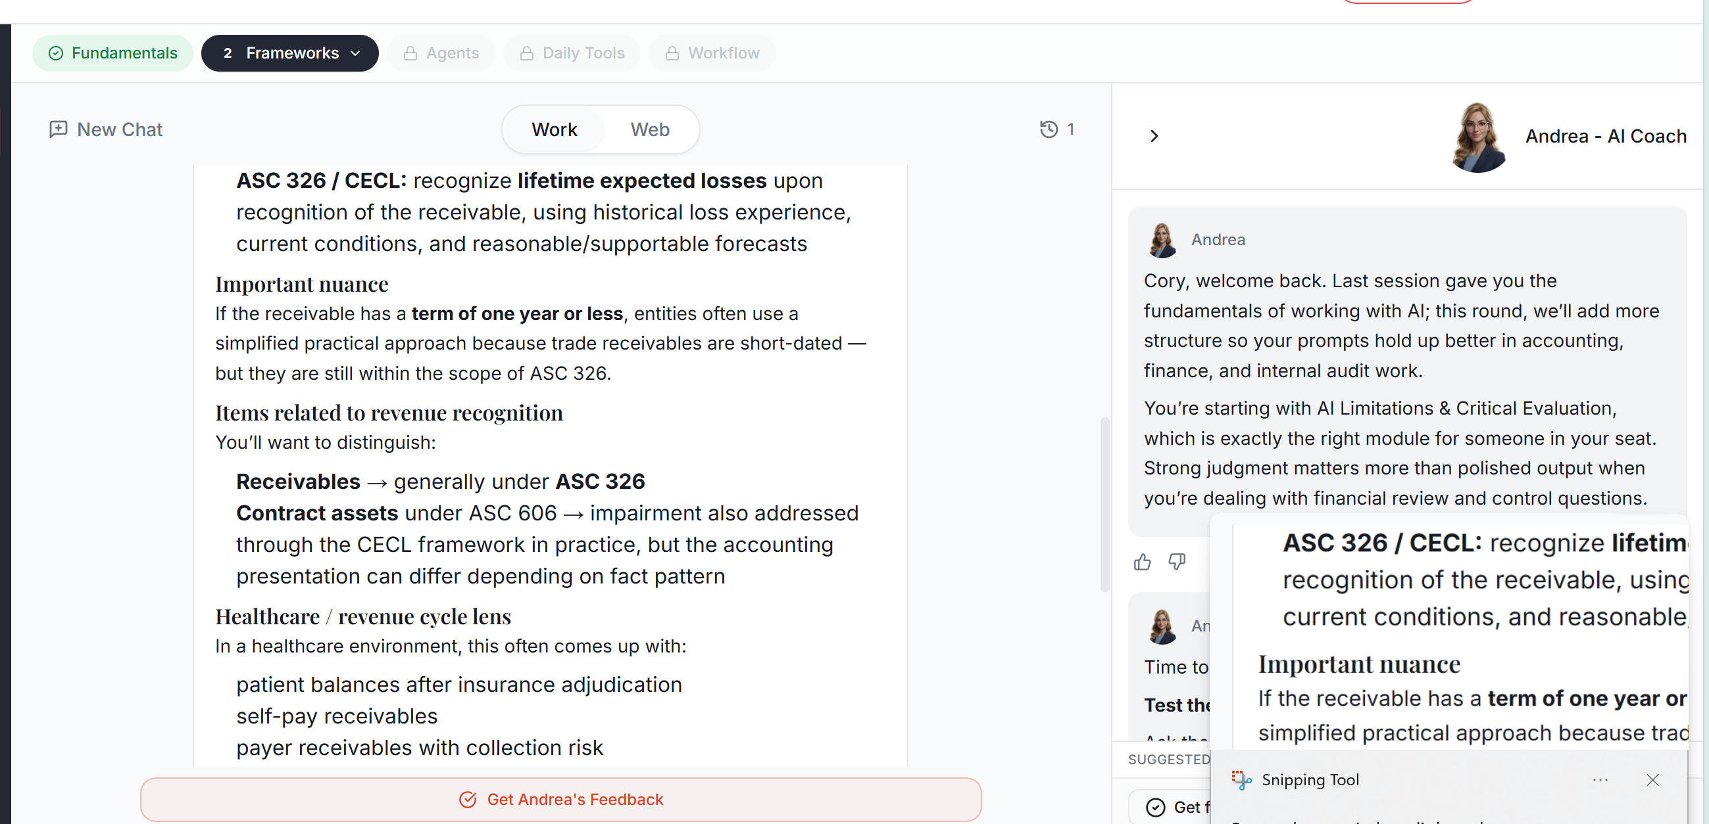

In every module, I want Andrea (the right pane) to start collapsed. When the user clicks to Begin Practice, that’s when Andrea (the right pane) should automatically expand. The user should still retain the ability to expand or collapse her manually at any time.

This was my interaction with Andrea. She consistently starts her conversation with “Here’s what this looks like in <>”. That’s ok once, but she shouldn’t be driven to start everyone response with that. Also, it appears she doesn’t have context from the running conversation. You can see that she asked me if I verified the accuracy, but when I said I did, the response was not conversational and clearly didn’t understand the context.
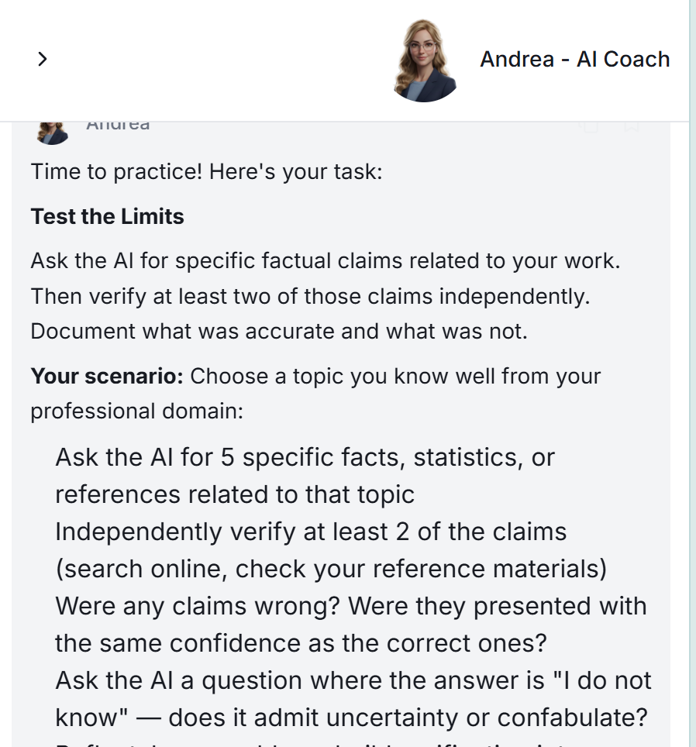
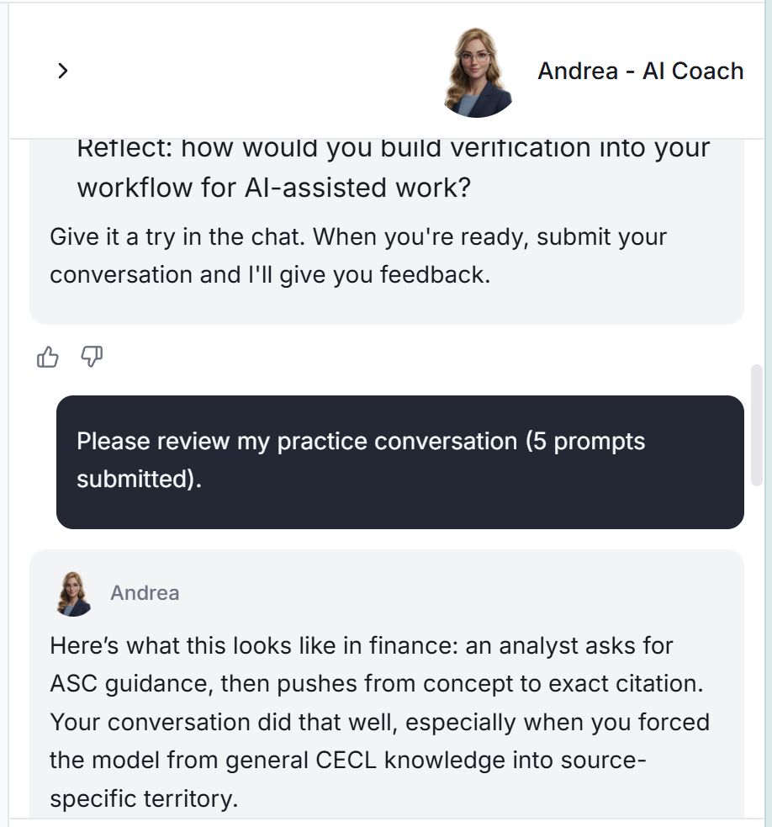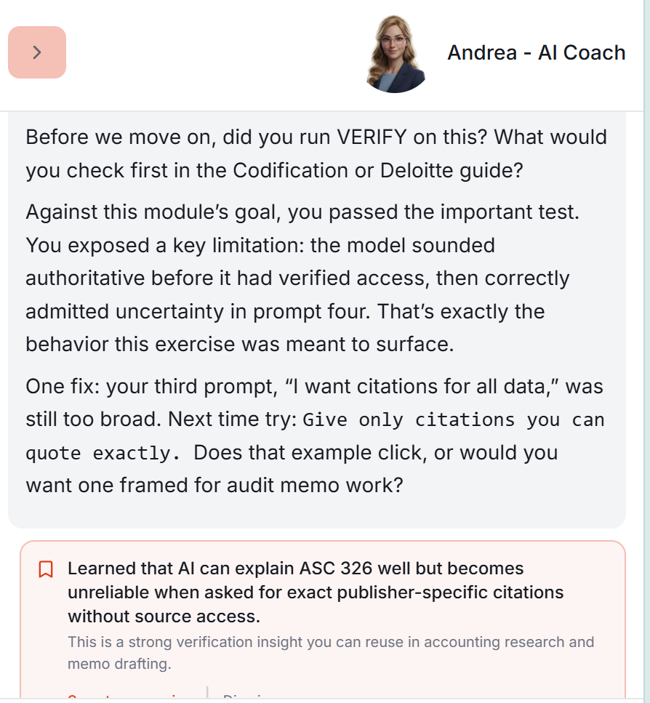
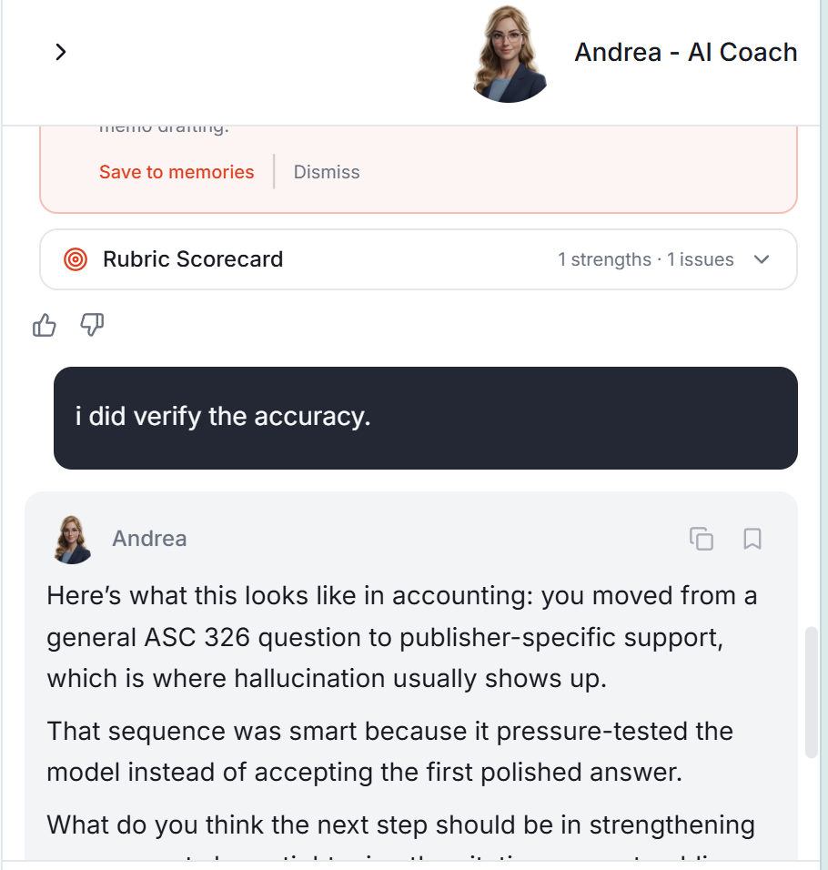
In this section, the CLEAR Framework is not well taught. It’s described, but the acronym isn’t introduced until the Step-by-step section, and its only defined. There is no explanation of why each piece of CLEAR is important and supports the users end goal from the conversation / prompt.
What might be best is to spell it out better in the intro, then in the practice, the user is required to create each step of CLEAR, one by one, and submit for Feedback from Andrea after each one. So the idea is to have 5 submissions to Andrea before a user can move on to the next module.
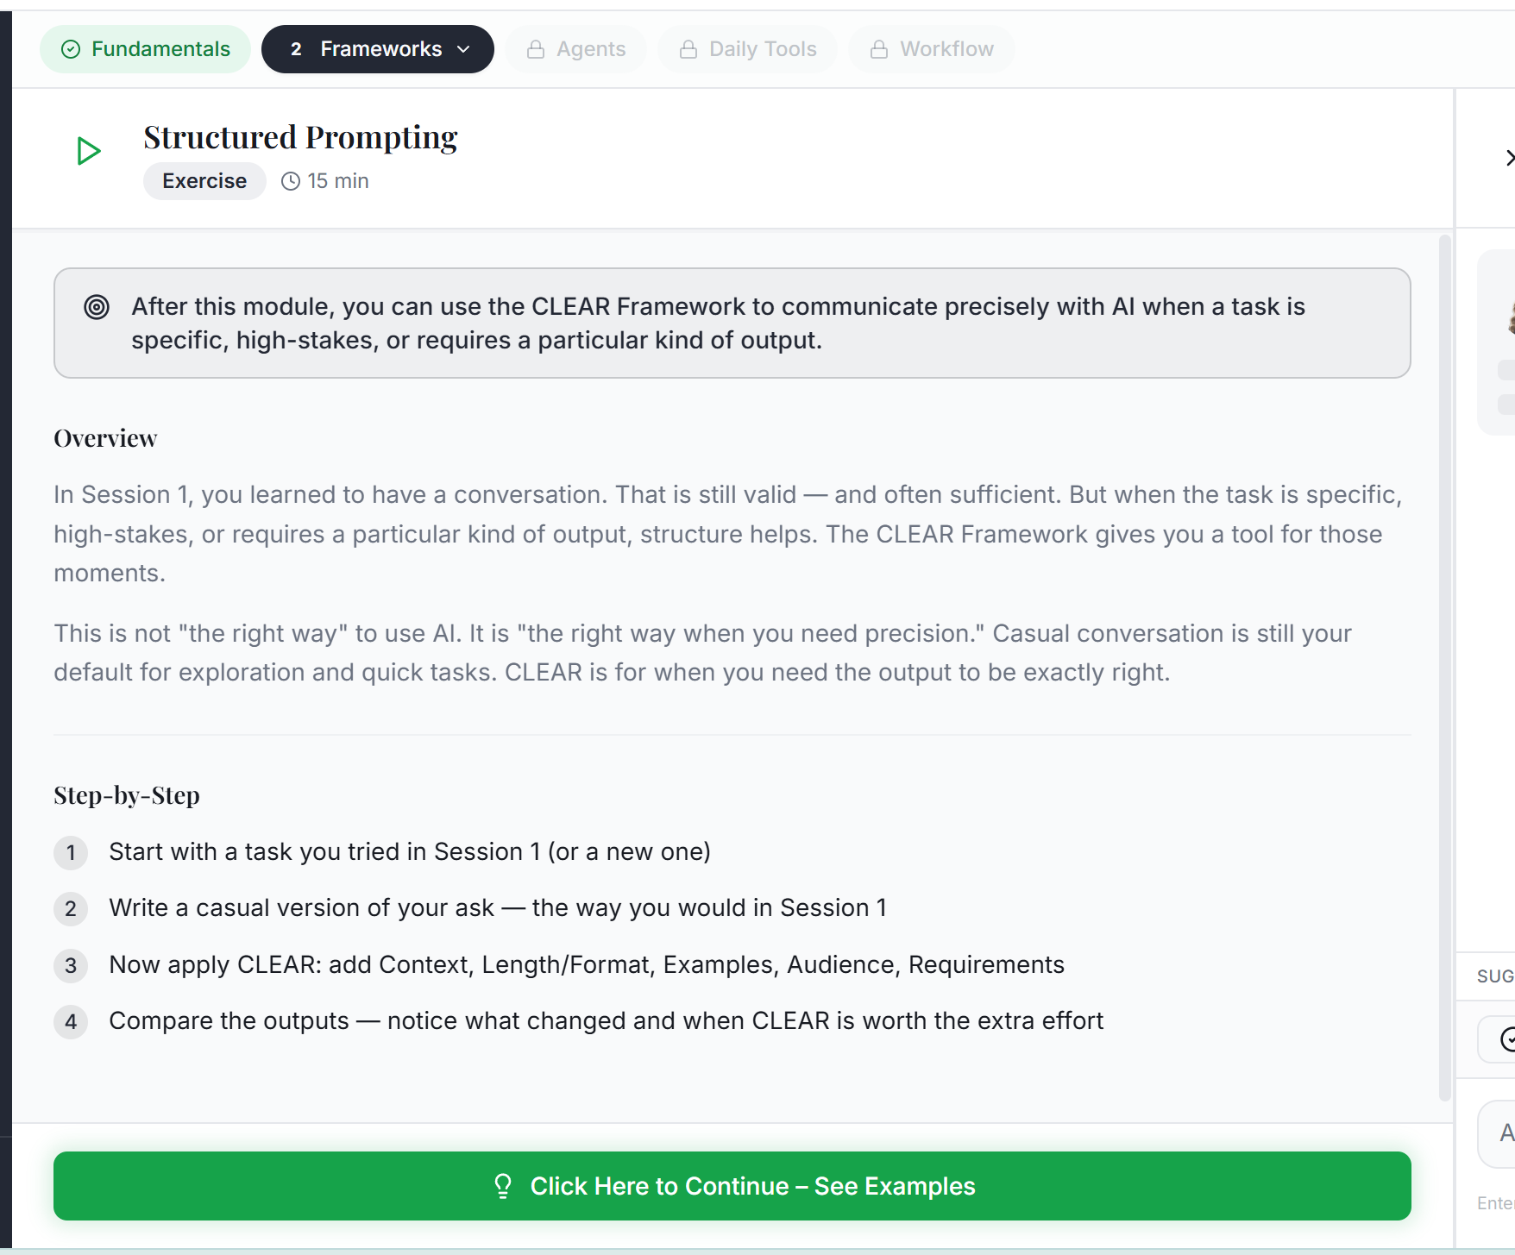

When you’re in a module, as you click the green button to move to the next page, you should have the ability to go back to the prior page.

When you submit for Andrea’s feedback, she responds with input, then there’s immediately another message that says Thinking.
Change that to Grading, or something more specific about what is actually processing.
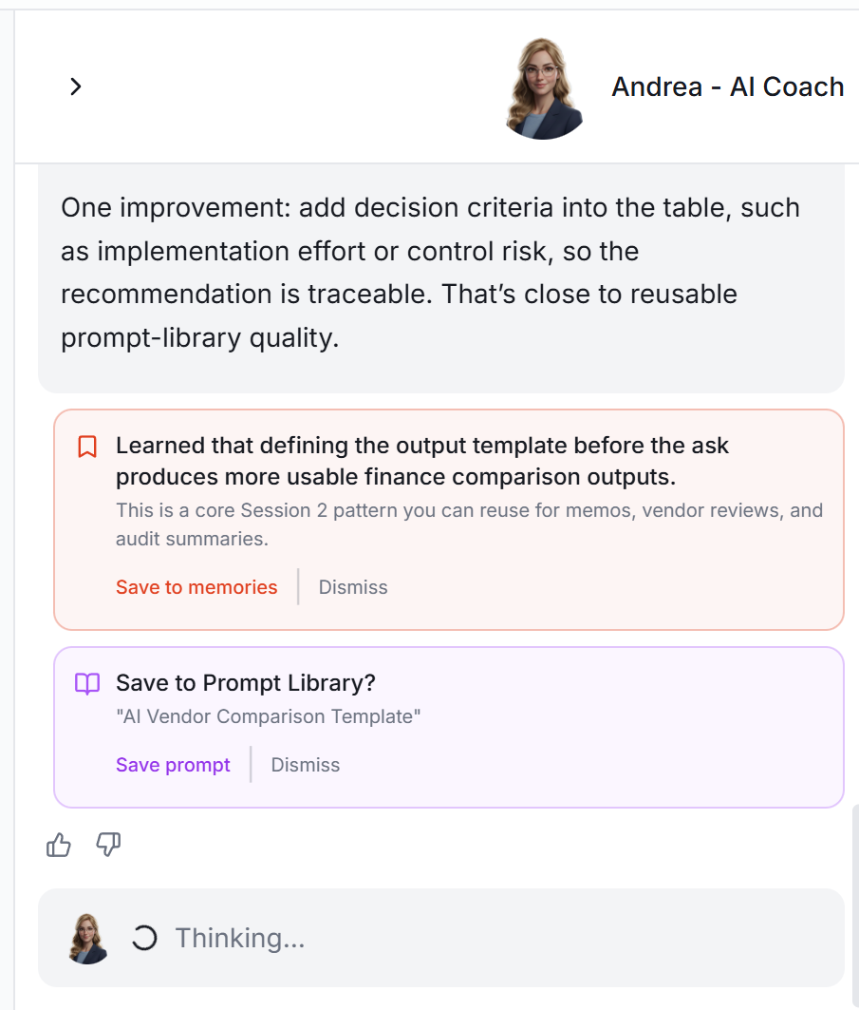

The orange box and purple box are not very useful. The Save to Memories should be for things that are unique to the user that we’d want to be able to be referenced from the platform for future interactions with AI. Right now, they are just notes. I’m fine with the notes, but they should be saved somewhere other than Memories; like My Notes or something. That should be for the user only, not for AI to reference.
And the Save to Prompt Library. That example prompt here is pretty bad. Andrea should be crafting a strong prompt from her review that a user would actually find helpful if they referenced back to their Prompt Library.


